Exercises about NTFS permissions

Imagine we have a computer with Windows 10 for two-year courses. The first year can access two types of students: hardware and software (2 users for each type and 1 group for the first year). The second year can access security and servers (2 users for each type and 1 group for the second year).
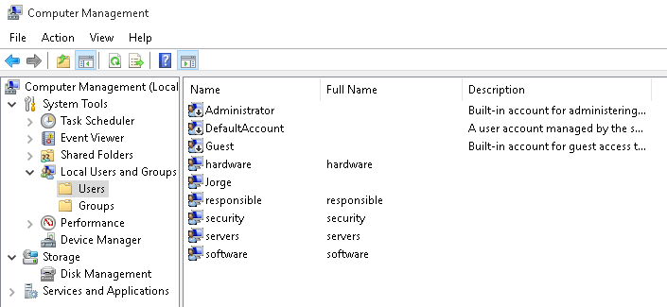
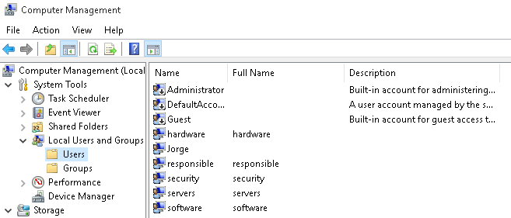
The users above are standard, but we also have an advanced user called “responsible” with administrator permissions.
We want to create some folders in D:\ according to the following criteria:
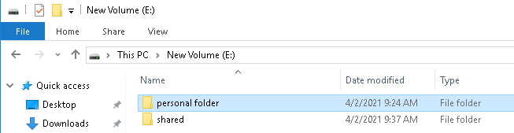
My D:\ was already occupied by my guest additions so I created “E”.
• A personal folder for each user, which can only be accessed by the corresponding user. They can do everything. You only need to create the folder for one of the users, since the others are similar.
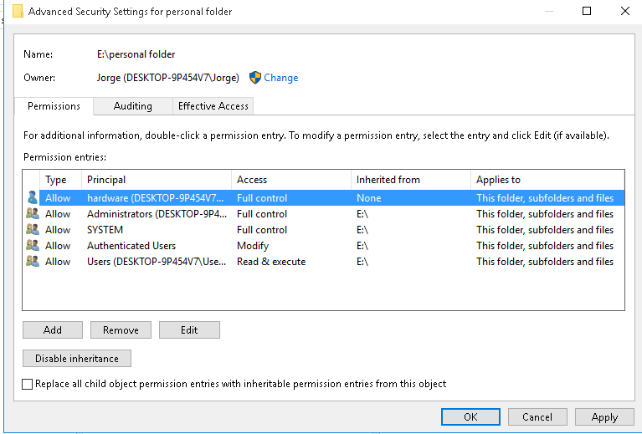
As an example, I created a folder with full control for the user “hardware”.
• A read-only folder for all the students called “shared”. The responsible user is able to create or delete files and folders. The software user cannot access this folder.
 | Allow |  |  |  |  | Deny
User/Group | Full Control | Modify | Read & Execute | Read | Write | Full Control | Modify | Read & Execute | Read | Write
first year group  (inherited) |  |  | x | x
second year group  (inherited) |  |  | x | x
Responsable user  (explicit) |  | X | X | X | x
software user  (explicit) |  |  |  |  |  |  |  | X | x

• A folder only for first year students into the shared folder, where they can create files and folders, but not delete them. Second year students will not be able to access.
 | Allow |  |  |  |  | Deny
User/Group | Full Control | Modify | Read & Execute | Read | Write | Full Control | Modify | Read & Execute | Read | Write
first year group  (inherited) |  |  | x | x | x
second year group  (explicit) |  |  |  |  |  |  |  | X | x

• Do the same as above for second year students (into the shared folder too). First year students will not be able to access.
 | Allow |  |  |  |  | Deny
User/Group | Full Control | Modify | Read & Execute | Read | Write | Full Control | Modify | Read & Execute | Read | Write
first year group  (inherited) |  |  |  |  |  |  |  | X | x
second year group  (explicit) |  |  | x | x | x

Do the following:
a) Explain the users and groups required for the computer.
The point to be efficient is to create, in order, first the “greater” object (let’s say the container or the default if we talk in terms if permissions) and then the “smaller” object (or the exception if we talk interms of permissions). So I firstly create 2 groups (one per course), with 2 users pending from each (one for each speciality).
b) Explain the folders we need according to the criteria above.
We need to create one personal folder for each student user with full control so we need to explicitly give according permissions. For the shared folder we can take advantage of the permissions that Windows assign to any standard group of users, and then, we modify specific permisions for specifi groups or users following the specific requirements.
c) Set the NTFS permissions for all the users and groups in each folder created in part B. For the subfolders, consider two scenarios: inheritance and non-inheritance.
You can use a table similar to below.
 | Allow |  |  |  |  | Deny
User/Group | Full Control | Modify | Read & Execute | Read | Write | Full Control | Modify | Read & Execute | Read | Write

